Binyam Mekonen

Unit-13
Website Design and Development

Table of Contents
- Introduction ........................................................................ 1
- Server Technologies and Management Services .......... 2
Domain Name System (DNS) ........................................ 2
- Communication Protocols and Server Components ........ 3
- Website Technologies, Tools, and Software ............. 4
Front-End and Back-End Technologies .......................... 4
- Merit-Level Analysis .................................................... 6
Impact of Web Development Technologies and Frameworks ... 6
Influence of Search Engines and SEO .......................... 7
- Distinction-Level Justification .................................... 8
Justification of Technologies for a Custom-Built Website ... 8
- Conclusion ........................................................................ 9
- References ........................................................................ 10

Web Technologies Analysis
Introduction
The executive summary states that web technology plays an important role in modern website design which includes the processes of developing, designing, hosting and website management. Web development process requires knowledge about the interaction between hardware/server technology, operating systems, web server software, communication protocols and other development tools to create secure and efficient web solutions. The report will investigate server technologies and management services which support website hosting together with their Domain Name Services (DNS) and hardware components and operating systems and web server software. The study will analyze Front-end and Back-end Web Technologies while comparing Online Website Creation Tools with Custom-built Websites and analyzing current web development frameworks to analyze how Search Engines affect Website Performance. The report explanation for web technologies will present arguments from web technology investigation and testing together with management services to assist the selected web technologies.
Server Technologies and Management Services
Domain Name System (DNS)
The Domain Name System (DNS) functions as a huge, decentralized network which changes human intelligible domain names into computer system or readable IP addresses and numerical data. The translation process exists because computers and network devices need to use IP addresses for their communication which excludes text-based names. DNS provides users with easy website access through methods which eliminate the requirement to memorize complicated numerical website addresses.
The internet structure starts with these top-level domains which lead to second level domains that go to subdomains. The Internet Corporate for Assigned Names and Numbers (ICANN) controls domain registration and DNS management through its accredited registrars and DNS hosting providers.
Communication Protocols and Server Components
The successful design, publication, and access of a website depend on the interaction among communication protocols, servers, hardware, operating systems and web server software. The communication protocols establish data transmission rules. Users request and receive web pages through HTTP and HTTPS, but HTTPS creates a secure channel with encrypted content. FTP and SFTP transfer website files to servers while TCP/IP delivers network data with complete accuracy. The physical infrastructure of server hardware enables businesses to establish and operate their websites. The system requires both physical servers and virtual machines that come with processors and memory and storage devices and network interfaces. The performance of a website is directly influenced by the capacity and configuration of this hardware. Operating systems such as Linux and Windows Server manage server resources and allow applications to run efficiently. Web hosting operators prefer Linux because it provides stable performance and secure environment and open-source accessibility. Web server software uses Apache Nginx and Microsoft IIS to handle incoming client requests while delivering web content to users. The system consists of multiple components which work together as one complete unit. A user sends an HTTP or HTTPS request to access a web page.
Website Technologies Tools Software
Front-End and Back-End Technologies
Website development requires integration of front-end development and back-end development to establish both presentation layer and application layer of the system. Front-end development technologies determine all visual aspects of a website while controlling all interactive elements that users use to navigate the site. The combination of HTML content structure definition and CSS layout design and color control and responsive design implementation with JavaScript dynamic website feature creation enables users to create animations and validate forms. The two technologies directly shape how users experience the system and how they navigate through its interface. Back-end technologies manage all server operations which involve processing data and handling data. The system uses PHP and Python and Node.js as programming languages to handle user requests while implementing business rules. The application uses MySQL and MongoDB to maintain user data and content and application information. APIs enable efficient communication between front-end systems and back-end systems. The front-end and back-end technologies work together to transform user actions into relevant results which establish complete operational web applications.
Online Website Creation Tools vs Custom-Built Websites
Online website creation tools such as Wix Canva and WordPress com enable users to create websites through their drag-and-drop interface and their collection of pre-built website templates. The tools enable users with basic technical skills to build websites quickly and they need limited technical training. The system provides basic design options, but it restricts users from achieving optimal performance levels while they use special features. The development teams of websites need to select specific programming languages together with frameworks and databases which they will use for their work. The system provides developers with tools to control all elements which include design, function, performance, user experience and user interface design. Businesses experience profits from custom-built websites because they require more time and specific skills to create.
Analyzing
The modern web development frameworks are changing. This is the way web sites develop and how well they are performing. For example, front-end technologies such as Bootstrap and Tailwind CSS help web sites to be consistent and perform well. JavaScript frameworks such as React, Angular, and Vue help web sites providing interactive, user interfaces with component-based approaches. The back-end frameworks Laravel and Django enable safe software development while offering protection and better system upkeep capabilities. WordPress and other Content Management Systems (CMS) enable users to update content with ease, but these systems restrict their ability to personalize their content. The implementation of frameworks accelerates the development process, yet excessive use of frameworks without proper optimization leads to performance problems for developers. The ability of search engines to assess website performance and user accessibility determines how well websites operate because they control which websites users can see. Ranking algorithms assess multiple factors which include tests of page load speed and evaluations of mobile device performance and content quality assessments and HTTPS security checks and backlink measurements. The website performance testing tools Google Page Speed Insights and Google Search Console and Arefs supply website owners with performance information and recommendations for website performance improvements. The implementation of image optimization and keyword targeting and structured data implementation techniques results in better index value and ranking. SEO practices lead to increased website traffic which results in better user experience and greater online authority for websites.

Justification of Technologies for a Custom-Built Website
Custom websites need technology because those technologies determine how the system can achieve optimal performance and maximum operational capacity. Developers need HTML and CSS and JavaScript for front-end design because these three languages enable them to build complete front-end systems while React provides a framework for building reusable user interface components. The system uses Node.js with Express as its server-side processing framework and MySQL for its structured data storage needs and Nginx as its high-performance web server and Linux as its operating system to maintain system stability and security. The selected technology stack determines all essential system attributes because developers must choose specific technologies to create their custom website. The stack functions through its different components which drive the system to reach maximum performance while enabling future growth. UI requires HTML, CSS, and JavaScript to create interactive user experiences. HTML provides the structural framework of the website. Semantic structuring is great for accessibility, SEO, and ease of maintenance. CSS (Cascading Style Sheets) is used to style the look of the website, including layout, fonts, and screen adaptation. Modern web development allows developers to create responsive designs across all screen sizes by employing the latest technologies like Flexbox and Grid. JavaScript enables dynamic functionality and client-side interactivity. It enables real-time validation of forms with asynchronous data retrieval and DOM content modification which creates a better user experience without needing to refresh the entire webpage. Developers use React as a JavaScript library to build reusable user interface components which improve front-end system performance and system capacity to handle increased workload. The component-based architecture of React enables developers to create modular systems which facilitate easier maintenance and system expansion. The Virtual DOM mechanism allows system components to assign only required interface and updates which results are in faster system performance. Additionally, as developers seek to optimize their websites for search engines and users used the most effective tools and technologies will have a direct impact on success. The report also highlighted the value of using current development practices and tools to create a website that meets an organization’s unique requirements. The review of various online webmaster resources demonstrated that using the latest web technology (including HTML5, CSS3 and JavaScript) provides the best opportunity to create a website that will meet or exceed user prediction.
Conclusion
The report will include an analysis of DNS management, server technologies, and website development tools. Using the report, the need to choose a particular technology for developing a custom website will be justified. It will be proved that custom websites have more advantages than online website building tools. In other words, there is an increasing need to utilize internet-based technologies for developing successful websites that are beneficial for both website developers and users. As the need for these services is increasing, website developers need to utilize the latest technologies in an efficient manner for developing successful websites that make users highly satisfied.

References
Cloudflare (2023) What is DNS? Available at: https://www.cloudflare.com/learning/dns/what-is-dns/ (Accessed: 10 February 2026).
Google (2023) Search Engine Optimization (SEO) Starter Guide. Available at: https://developers.google.com/search/docs/fundamentals/seo-starter-guide (Accessed: 10 February 2026).
Mozilla Developer Network (MDN) (2024) Web Technologies for Developers. Available at: https://developer.mozilla.org (Accessed: 10 February 2026).
W3C (2023) Web Architecture. Available at: https://www.w3.org/standards/webarch/ (Accessed: 10 February 2026).

Martial Arts Academy Website
Activity 2 (LO3): Website Design, Implementation and Testing
Introduction
Digital technologies serve as the primary means of communication in businesses use to interact with their customers. The Martial Arts Academy needs a professional website enable organization to market its programs and bring in new students. A properly built website establishes trustworthiness through better communication tools. The project targets the creation of a multipage website which will fulfill the requirements of both the business operations and the end users. The solution needs to deliver operational capabilities together with protection features and access for all users and design elements that match the academy's visual brand standards.
Requirements Analysis
The requirements emerged from three sources which included analysis of existing martial arts websites and user needs and business target assessment. The academy requires an online presence that supports marketing and enables communication and student registration activities.
Functional Requirements
The website must provide information about the academy which includes its historical background and mission statement.
The website must display different martial programs. For example, show instructor profiles, present class schedules, include a gallery page which displays training images….The website must allow users to navigate through its content in an easy way. The system needs online registration as its core function because it streamlines the process of student enrollment through an automated system which reduces manual tasks while making it easier for customers to register.
Non-Functional Requirements
The website should load within short seconds, display content properly, implement HTTPS encryption, provide users with easy website navigation which delivers high usability…. The requirements establish basic standards which digital platforms must meet to ensure they perform reliably and maintain secure operations while delivering accessible content to all users.
User Acceptance Criteria
The website will be considered successful, if functions correctly. Because all links between pages operate without errors The website functions correctly because forms validate user input and send data successfully to the server. The website displays no broken images and displays content properly on mobile devices. AND the website enables users to find essential information through simple clicks.

Design Documentation
Wireframes: Wireframes were created for the following pages;Home, About, Classes, Gallery, Contact and Registration.
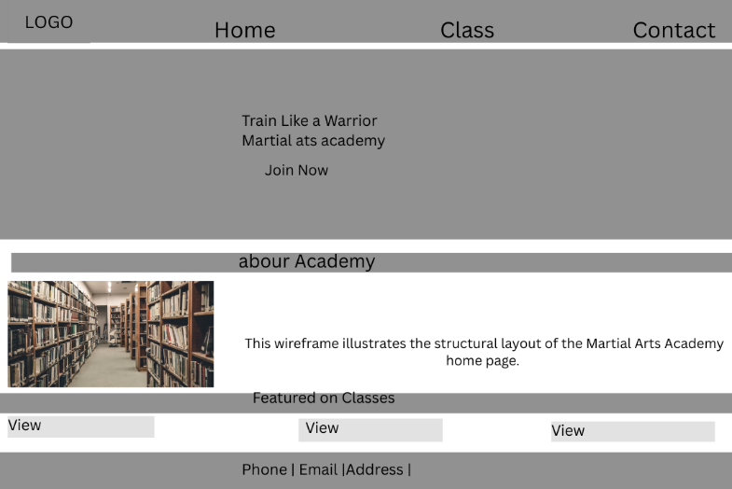



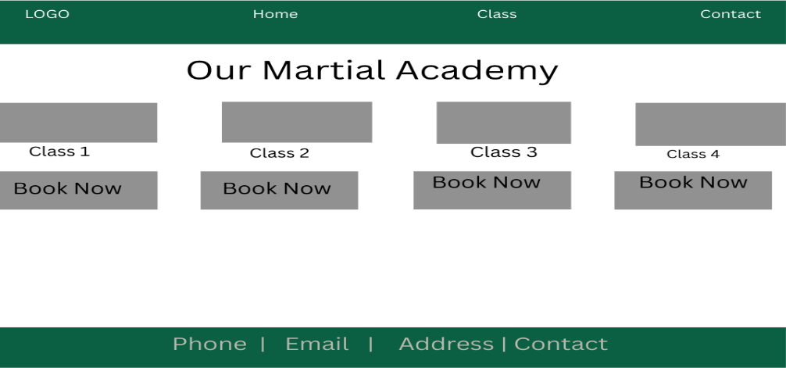
The wireframes follow a consistent structure: Header with logo and navigation, Main content area, Call-to-action buttons and Footer with contact information and social media links. A multipage structure was selected instead of a single scrolling page because it improves content organisation and enhances navigation efficiency.
Interface Design
Colour Scheme
- Black: represents strength and discipline.
- Red: symbolises energy and power.
- White: ensures readability and contrast.
Typography: Headings for Bold sans-serif font for strong visual hierarchy and Body text for Clean readable font for clarity.
Layout Decisions: Visual hierarchy was implemented through large headings, contrasting buttons, and structured content sections. Consistency across pages ensures familiarity and ease of navigation.

Networking and Hosting Considerations
The website requires:
- A registered domain name (e.g., martialartsacademy.com).
- Shared hosting as a cost-effective starting solution.
- SSL certificate for HTTPS encryption.
- The system needs to achieve at least 99.9% uptime reliability.
Cloud hosting could be implemented in the future if traffic increases significantly.
Security Features
The implemented security measures protect the system through:
- SSL encryption which protects user data.
- Client-side and server-side form validation.
- CAPTCHA protection which stops spam submissions.
- Secure coding practices which reduce the chances of cross-site scripting (XSS) and SQL injection attacks.
- The website data which is backed up on a regular basis.

Accessibility and Inclusivity
The website follows steps
  - Providing alt text for all images.
  - Ensuring sufficient colour contrast ratios.
  - Using readable font sizes (minimum 16px).
  - Supporting keyboard navigation.
  - Structuring content with proper semantic HTML.
The implementation of these design elements enables users with visual or physical disabilities to access content while creating an environment that supports digital outreach to all users.
Website Implementation
The website was developed using:
• HTML5 for structure.
• CSS3 for styling.
• JavaScript for interactivity and validation.
• Bootstrap framework to enhance responsiveness.
The website contains six pages which are interconnected and provide users with consistent branding and navigation. The development team made minor layout changes from the original wireframes to enhance mobile responsiveness.
Home page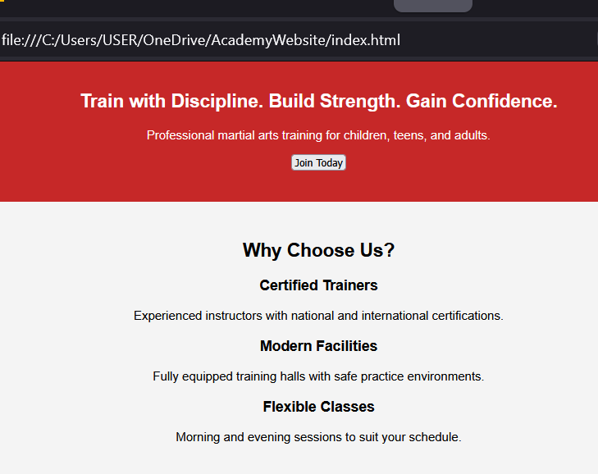

Abou page


Class page
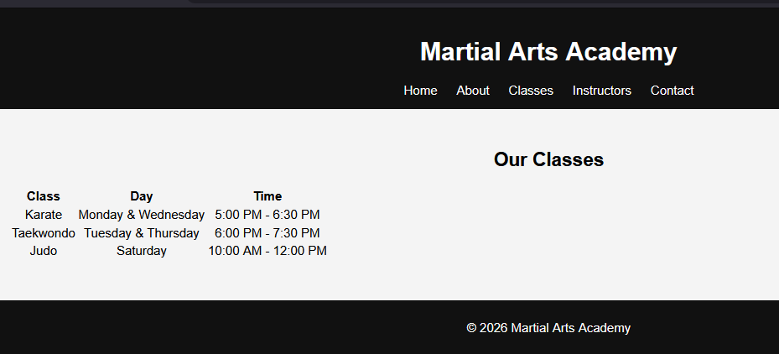
Instructors Page

Contact page


Testing Plan and Quality Assurance Analysis & Evaluation
This segment assesses the various aspects of the Martial Arts Academy (e.g., functionality, usability, performance, and design) based on a standardized method of assessment. By undertaking systematic test planning, essential aspects of the Martial Arts Academy website (i.e., navigation, usability, mobile-friendly, and other performance metrics) can be determined. During development, all quality assurance (QA) methodology was followed, thus establishing that an end-user requirement was met. The results of the testing and analysis will be used to judge whether or not the end-user requirement has been successfully met, however; also to provide recommendations to improve the website.
Testing Plan Developing a Functional Martial Arts Academy Website
The goal of Testing
The aim of testing the Martial Arts Academy website is to make sure that all users can easily:
• Search for classes (karate, taekwondo and judo)
• Provide registration or general interest to the academy
• Visit all other pages after one page is visited (no dead links)
• Accessible on all devices and screen sizes
Key Pages Tested
• Homepage
• About
• Classes
• Timetable
• Contact Us
Tools Used to test
• Browser Development Tools
• Google Lighthouse
• Manual Testing
• Mobile Tests

Quality Assurance (QA) Assessment
1. Quality Assurance (QA) During Planning:
• We identified target users, such as the students and their parents.
• We planned the necessary pages such as the class schedule, timetable and contact details.
Analysis
This helped ensure the Structure of the website was designed from the start for the best possible outcome for users.
2. Quality Assurance (QA) Assessment During Design:
  - Used a clear layout and implemented a martial arts theme throughout Design.
  - Fonts were easy to read and color contrast was sufficient to ensure visibility.
Analysis
Improvements to usability and clarity were made for the end users.
3. Quality Assurance (QA) Analysis After Development:
• All pages were tested after each page or group of pages was created.
• All broken links were corrected immediately after they were found.
• All pages were checked to verify they were working correctly.
Analysis
This early testing revealed any major issues that existed and was a great time saver for developing.
4. Quality Assurance (QA) Assessment During Testing:
• A complete test plan was executed throughout the testing phase.
• All functionality was verified and confirmed by our test team.
Analysis
The test team ensured that the site was fully operational prior to the delivery of the final site to the client.
Strengths
• Continuous testing throughout development.
• Immediate correction of any bugs found.
• Improved quality of the final product.
6. Weaknesses:
• Time-intensive process.
• Limited amount of advanced testing tools used.
D3 – Evaluation and Suggestions
Successful Website
The Martial Arts Academy's website is deemed to be successful in these areas:
• All pages are functional
• Navigation is seamless
• The design is user-friendly
• Web-based functionality on mobile devices
Strengths
✔ The website's layout and structure are clear.
✔ Fast Load Times
✔ Easy access to class information
✔ The contact form operates correctly.
Weaknesses
- Larger graphical images impact load times negatively
- Mild alignment issues with mobile viewing of the pages
- Limited security features provided for users to protect sensitive data entered on forms
Suggestion for Improvements
- Compress Graphic Images
- Use Caching Usability
- Balance spacing of pages on Mobile Devices
- Search Function

Security: Implement CAPTCHA on forms and Increase user data validation
Future Additions: Online booking system to register for classes, Payment Method Integration and User Login/Dashboard
5. Conclusion
Overall, the Martial Arts Academy's website meets the intended goal of creating an enjoyable user experience for the users of the site. The quality assurance (QA) process was successful in creating a reliable and functional website. After minor adjustments, the Martial Arts Academy will be able to further increase its performance as well as provide more pleasurable experiences to its users.

